**Services:**

A shared class is a service.

Services are often utility classes.

A service is instantiated once and then injected in the classes that need it.

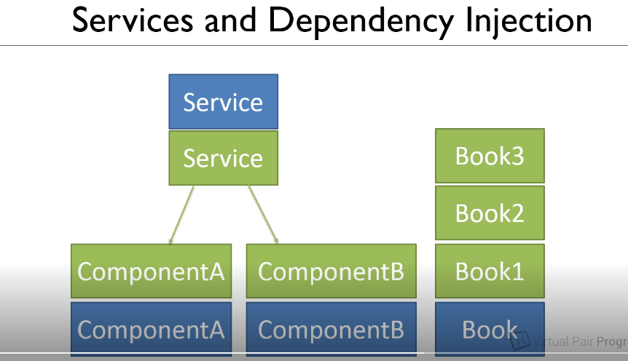

**Creating a Service:**

**ng generate service data**

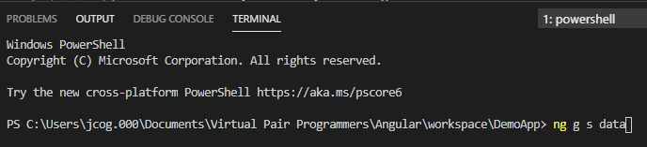

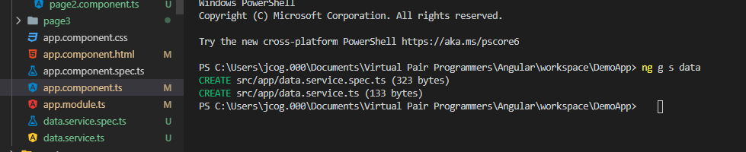

**Create a model folder in the app directory, for the Book class and create a Book.ts file**

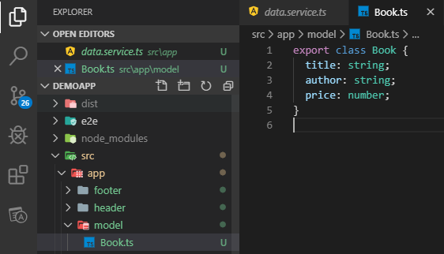

**Create an array of books, create 3 books in the constructor, all within the data.ts file**

**This data service is injected at root so available throughout the app**

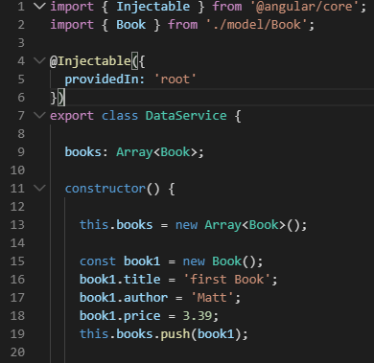

**Dependency Injection:**

**Open page1 class or page1.component.ts file and in the constructor inject the data.**

**We put a param in the constructor**

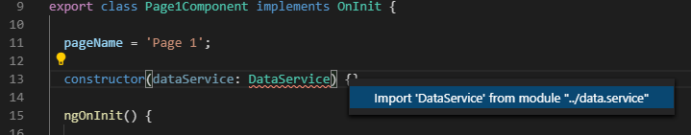

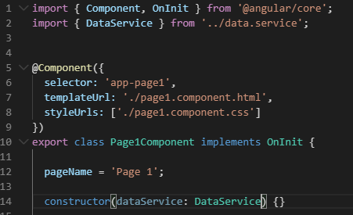

**Modify the data service as private**



**Add a local variable data for page1 to pass the private dataService to the page1 html page**

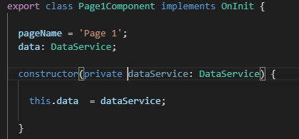



**Demo the data available:**

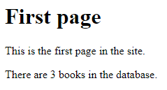

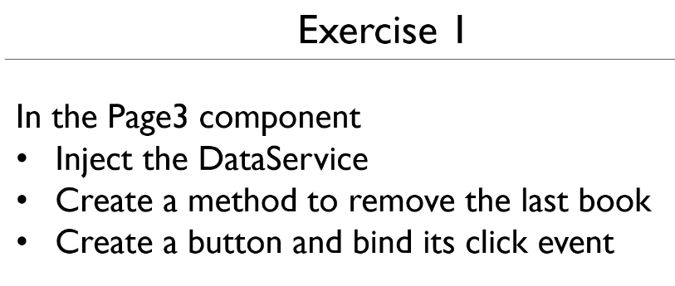

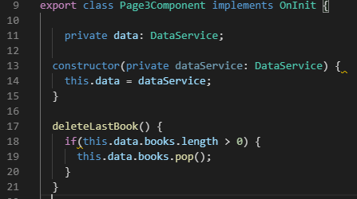

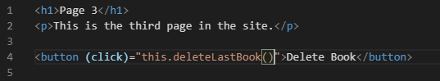

**Demo: Click the button and check page2 for how many books:**

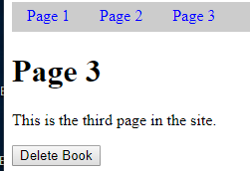

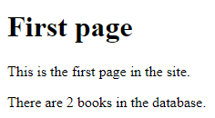

**It works!!**